BACK TO YOUR ROOTS: A Sustainable Agriculture Masters Series
Growing Food, Farmers & the Fabric of Rural Communities
May 17 – 19, 2018
Northwestern State University
Russell Hall
125 Central Avenue
Natchitoches, Louisiana 71457

CONFERENCE OVERVIEW

Campti Field of Dreams, Inc. is a Louisiana nonprofit organization, founded in 2001, dedicated to improving the quality of life of those in rural communities. We operate the Campti Historic Museum, Jackson Square Community Garden and Tallowah Farm: a twenty-five acre sustainable agriculture demonstration farm. We develop programs that will enhance the Culture, Health, Education, Employment, Safety and Security and the Environment both Built and Natural of residents in rural communities. So when we say sustainable development, we think CHEESE!

THE NEED: REBUILD OUR LOCAL FOOD SYSTEM, THE BACKBONE OF RURAL ECONOMIES
Right now, our rural communities are facing a challenge. According to DRA: Louisiana’s Regional Development Plan, “Louisiana faces profound concerns related to persistent poverty, out-migration, health, education, and income levels. These socio-economic factors indicate that Louisiana must utilize traditional and non-traditional community and economic development strategies in the future. Community and economic development strategies must evolve in order to be successful.”

Louisiana was built on agriculture and the majority were small farmers and ranchers. According to, The State of Louisiana, “The vast majority of rural whites and free blacks lived on small or modest-sized holdings and owned no slaves, or at most a few, with whom they worked side by side in the fields. Many of Louisiana's farmers and ranchers were Acadians (also known as Cajuns), Germans, Isleños (Spaniards from the Canary Islands), Anglo Americans, free African Americans, and American Indians. They raised food and livestock, spun and wove, fished, and hunted game for their own consumption, selling any surplus goods and crops in neighboring towns and cities.” This created the strong local food system in which Louisiana is rooted. https://www.crt.state.la.us/louisiana-state-museum/online-exhibits/the-cabildo/antebellum-louisiana-agrarian-life/) It also leads to the rich cultural heritage for which we are renown and loved. American Heritage fondly describes Louisiana cuisine as, “the literal melting pot of America.” They note, “In a pot of gumbo served today in a traditional New Orleans house, there is a French roux, African okra, Indian filé , Spanish peppers, Cajun sausage, and oysters supplied by a Yugoslav fisherman, all served over Chinese rice with an accompaniment of hot French bread made by one of the city’s finest German bakers.” (Source: https://www.americanheritage.com/content/true-and-delectable-history-creole-cooking#main-content) To develop the thriving communities of tomorrow, Louisiana, it is time to go “Back To Your Roots!”

THE FACTS: PERSISTENT POVERTY IS STIFLING OUR RURAL COMMUNITIES
- The median household income in Louisiana is $12,471 less than the U.S. median household income.
- Over 20 percent of the population lives in poverty
- Farmers are aging fast and small family farms are dying off because of the notion that you cannot make a living farming.

THE ANSWER: EMPOWER A NEW GENERATION OF FARMERS WITH MODELS THAT ARE FINANCIALLY LUCRATIVE, REPLICABLE AND SCALABLE TO INFUSE INNOVATION AND SUSTAINABLE ENTREPRENEURSHIP INTO OUR RURAL ECONOMIES
The goals of the conference are:
- Advance sustainable agriculture as a tool for community revitalization in parishes facing persistent poverty by rebuilding the local food system and other creative placemaking initiatives.
- Educate the public on the environmental benefits of organic production and the mutually beneficial programs provided by USDA Natural Resources Conservation Service.
- Inspire a new generation of farmers.
- Last, but definitely not least, dispel the myth that you can’t make money farming!
Back To Your Roots 2018 is pleased to bring you three internationally renown Masters in their fields along with other academics, farmers, ranchers and value-added producers who will share their expertise with you. Join us for a transformational event!

Thursday, May 17 | Friday, May 18 | Saturday, May 19
 |  | 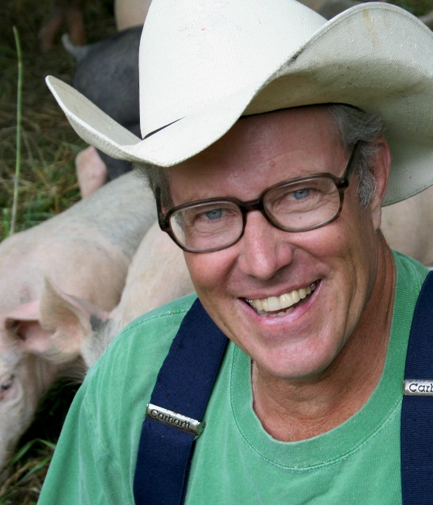
Dr. Chuck Fluharty, President & CEO, Rural Policy Research Institute  Thinking “Bigger” About Smaller Places: Capturing the “Adjacent Possible” Innovations  “Since our nation’s founding, rural areas and rural people have provided the food, fuel, and fiber for all our citizens. Today, as never before, the health, welfare, and future viability of urban America are directly linked to the wellbeing of rural America.” | Jean-Martin Fortier, Farmer & Author,  The Market Gardener  Making a Good Living with Profitable Market Gardening on 1.5 Acres  “We need to replace mass production with production by the masses.” | Joel Salatin,  Third Generation Farmer & Author:  You Can Farm, Salad Bar Beef, Pastured Poultry Profits and Many More  Polyface Masterclass: Sustainable Farm Enterprises  “Know you food, know your farmers, and know your kitchen.” “You can't have a healthy civilization without healthy soil. You can't have junk food and have healthy people.”

